REL126: Ancient Egypt: Magic and Civilization

MTuWTh 12:45-3:00 PM F 8:45-11:00 AM Classroom: Thomas Commons MLK

Professor Steven Daniel Sacks    Office: Prall 108

This course will provide both an introduction to the religion of Ancient Egypt - investigating the essential issues of Ancient Near Eastern literature, culture and civilization - as well as an exploration of Egypt as a symbol of magic and esoteric wisdom from Late Antiquity to the Present.

The content and methods in this course correspond to Cornell’s educational priorities:

1. **Knowledge**: Students will integrate and apply knowledge from an interdisciplinary perspective in order to understand the topics of Religion; since no methodology of the academy is “native” to the study of religion, a variety of methodological perspectives are employed in this course.
2. **Inquiry**: Students will encounter a variety of interpretive schema, and will be asked to produce critical analysis to discern the benefits and detriments of differing interpretations and positions.
3. **Communication**:Students will be asked to develop skills in oral presentation and argumentation in every class session and in formal written assignments, and to provide clear structured arguments, with ample use of source materials, on written assignments.
4. **Intercultural Literacy:** Students will be asked to identify with, argue on behalf of, and critique a wide variety of perspectives and positions with which they do not personally identify.
5. **Ethical Behavior:** The study of the history and interpretation of religion is an ethical endeavor.

Class attendance and participation are compulsory for this course, as is the originality of your work; absences without verifiable cause or plagiarism will be cause for failing grades. Late final papers or missed exams will be subject to a minimum of a half-grade penalty. Failure to submit an assignment will be penalized by failure in the course. Those with disabilities must request accommodation from the instructor within the first three days of the course.

Grading:

Class attendance and participation 25%

Paper (2) 50%

Exam (1) 25%

All readings are listed below, due on the day that they appear, and may be downloaded from our Moodle forum. You are expected to bring your readings to class every day.

I will hold regular office hours before class 10:00-11:00 MTuWTh, but please feel free to contact me at any time if you have questions or concerns about the course. The present schedule and/or readings are liable to be amended as is necessary. Students are expected to complete a significant amount of work outside of the course which supplements scheduled hours within the classroom, and exceeds the government’s regulations on course credit equivalency.

Cornell College expects all members of the Cornell community to act with academic integrity. An important aspect of academic integrity is respecting the work of others. A student is expected to explicitly acknowledge ideas, claims, observations, or data of others, unless generally known. When a piece of work is submitted for credit, a student is asserting that the submission is her or his work unless there is a citation of a specific source. If there is no appropriate acknowledgement of sources, whether intended or not, this may constitute a violation of the College’s requirement for honesty in academic work and may be treated as a case of academic dishonesty. The procedures regarding how the College deals with cases of academic dishonesty appear in The Catalogue, under the heading “Academic Honesty.”

Students who need accommodations for learning disabilities must provide documentation from a professional qualified to diagnose learning disabilities. For more information see cornellcollege.edu/disabilities/documentation/index.shtml

In order to prepare for each class, you will be required to do the following:

1. Marginalia: Print out every reading, and every time you feel the urge to highlight or underline something, write out in the margins why you wanted to underline it. Why is that passage important? Is it a major new point in the argument? A significant piece of support? A summary of the opposition? A particularly strong or particularly weak point? Use the margins to summarize the text, ask questions, give assent and protest vehemently – do not just color the pages. You will scan and electronically submit your marginalia on Fridays.
2. Leadership: Every day one member of your group will assume the role of leader and (a) compose and post a thesis seeking question to our moodle forum by 7:00 PM the evening before class; this question will seek to clarify the intent and/or argument of our readings – the question will not address questions of fact or content, but rather arguments presented in our readings; (b) observe, record and present the group’s consensus solution from class and online discussion; the product should not be a summary of “what the group talked about” but a persuasive presentation of the group’s work, and summary of their consensus solution to a problem in a one sentence thesis statement, where appropriate. All written efforts should be posted on Moodle.
3. Online Circular Response: In response to a question posed by the day’s leader, every member of the group will post a response on our moodle forum of at least three sentences. Unless you are the first to respond, every member of the group is expected to post with a reference to the observations and views of a previous classmate’s contribution and make specific reference to the reading itself. All responses are due a minimum of two hours before class.

Rubrics

Class Participation:

The grade for class participation will be categorized as follows: “A” for exceptional contributions to our daily discussions and the Moodle forum, with no missing or late assignments. “A-“ for exceptional contributions, with one missing or late assignment; “B+” for excellent and consistent contributions to our daily discussions and the Moodle forum; “B” for solid contributions to our daily discussions or Moodle forum, with one or two missing or late assignments; “B-” for uneven contributions to our daily discussion or the Moodle forum; C+ for uneven contributions to our daily discussion and the Moodle forum, with two or three missing or late assignments; “C” and below for poor effort to participate in our daily discussions and the moodle forum, with three or more missing or late assignments.

Papers:

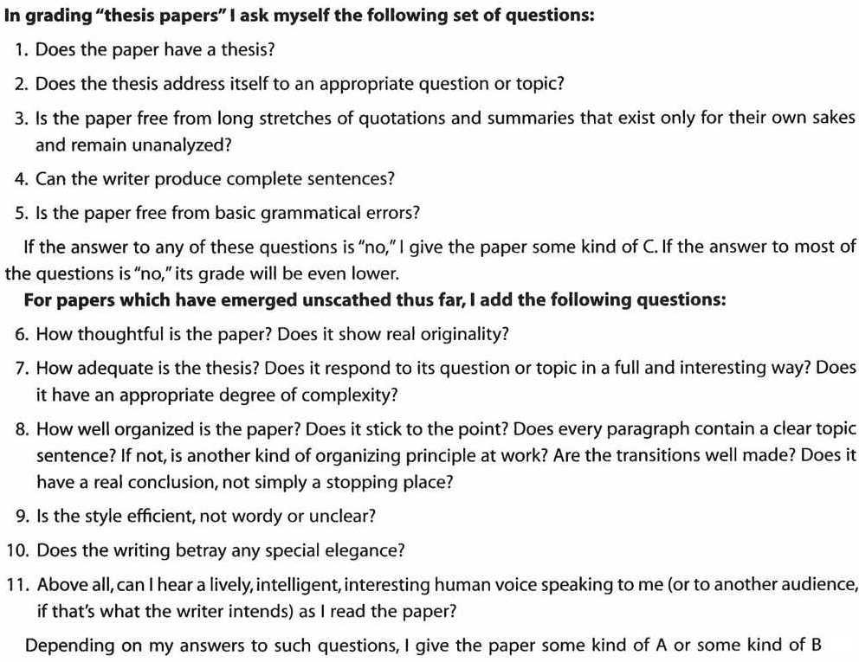

Schedule

Monday, September 24:

Culianu *Eros and Magic in the Renaissance* xvii-xviii.

D. Silverman *Ancient Egypt* 20-39.

Tuesday, September 25:

E. Hornung *Conceptions of God in Ancient Egypt* 66-99.

D. Silverman *Ancient Egypt* 90-131.

Wednesday, September 26:

J. Assmann *The Search for God in Ancient Egypt* 1-13 and 111-147.

D. Silverman *Ancient Egypt* 132-147.

FILM: Robert Ritner “A Game of Thrones and Coffins”

Thursday, September 27:

H. Frankfort *Kingship and The Gods* 3-35 and 51-78.

D. Silverman *Ancient Egypt* 148-164.

Friday, September 28:

R. Ritner *The Mechanics of Ancient Egyptian Magical Practice* 14-28.

*The Literature of Ancient Egypt* 247-262 and 278-283.

Monday, October 1:

**FILM: *\*\*Romer’s Egypt*\*\***

**\*\*First Paper Due\*\***

Tuesday, October 2:

R. Ritner *The Mechanics of Ancient Egyptian Magical Practice* 111-190.

Wednesday, October 3:

J. Allen *Middle Egyptian* 1-24.

Iamblichus, *On the Mysteries*, 291*-*325.

Thursday, October 4:

*Ancient Mysteries* 157-196

*The Literature of Ancient Egypt* 470-489.

Friday, October 5:

F. Yates *Giordano Bruno and the Hermetic Tradition* 1-61.

Monday, October 8:

B. Curran *The Egyptian Renaissance* 65-131.

Tuesday, October 9:

Walker, D.P. *Spiritual & Demonic Magic* 75-84

Culianu *Eros and Magic in the Renaissance* 87-129

Wednesday, October 10:

M. Blavatsky *The Secret Doctrine* II 590, 630-641.

C. Johnston *The Religion of Ancient Egypt* 380-390.

Thursday, October 11:

Freud, S. *Totem and Taboo* 94-124.

Freud, S. *The Uncanny* 123-159.

Friday, October 12:

**\*\*\*Exam\*\*\***

Monday, October 15:

J. Bailey, *Sacred Not Secret*

M. Redd, Astro-Black Mythology *The Poetry of Sun Ra*

**FILM:** Sun Ra *Space is the Place*

Tuesday, October 16:

*The Joseph Smith Egyptian Papyri* 3-9

*The Egyptian Miracle* 7-12

Wednesday, October 17:

**\*\*Final Paper Due\*\***